Q1: Print elements diagonally

#include<stdio.h>

int main()

{

int m,n,i,j,x,k;

scanf("%d%d",&m,&n);

int a[m][n];

for (i=0;i<m;i++)

{

for (j=0;j<n;j++)

{

scanf("%d",&a[i][j]);

}

}

for (i=0;i<m;i++)

{

x=i;

for (j=0;j<=i;j++)

{

printf("%d ",a[x][j]);

x--;

}

printf("\n");

}

i=n-1;

for (j=1;j<n;j++)

{

x=i;

for (k=j;k<n;k++)

{

printf("%d ",a[x][k]);

x--;

}

printf("\n");

}

return 0;

}

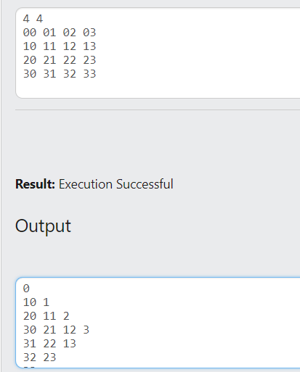

#include<stdio.h>

int main()

{

int i,j,r,c,n,t;

scanf("%d",&n);

int a[n];

for(i=0;i<n;i++)

scanf("%d",&a[i]);

scanf("%d",&t);

if (n%2==0)

{

for (i=0;i<n;i++)

{

if (a[i]%2==0)

printf("%d ",a[i]);

}

}

else

{

r=n%t;

for (i=0;i<n-r;i+=t)

{

c=0;

for(j=i;j<i+t;j++)

if (a[j]%2==0)

{

c++;

}

printf("%d ",c);

}

c=0;

for (i=n-r;i<n;i++)

if (a[i]%2==0)

{

c++;

}

if (c!=0)

printf("%d",c);

}

}

